Linked List Practice 1

- What does this code print?

public class Driver {
public static void println(ListNode list) {
while (list != null) {
System.out.print(list.getValue() + " ");
list = list.getNext();
}
System.out.println();
}
public static void main(String[] args) {
ListNode head = new ListNode(new Integer(1), null);
ListNode a = new ListNode(new Integer(2), head);
ListNode b = new ListNode(new Integer(3), a);

println(head);
println(a);
println(b);
}
}

- Using no more that one semicolon in your statement(s), create a linked list of 3 nodes (see picture).

1
2
3
head

- Using our ListNode, write a method called rotateHeadToEnd which, given a parameter called head of type ListNode, splits off the head of the list and puts it at the end of the list. Write your own heading for the method (this is important – depending on how you do it, you might have a different method heading than the next guy/gal). You may not create any new memory (i.e., you can’t use new).

- Write the method below recursively:

// pre: head is pointing at a (possibly empty) linked list
// post: returns the number of nodes in the list pointed to by head
public int countNodes(ListNode head) {

- Write a method called removeNodes which has 2 parameters, head and thingToRemove. removeNodes removes all nodes in the list pointed to by head which have data contents equal to the parameter thingToRemove.

public ListNode removeNodes(ListNode head, Object thingToRemove) {

6.

Part A

Write method firstMin, whose header is given below. firstMin determines the value of the
smallest integer(Integer) in its list parameter and returns a pointer to the first node in the list that contains
that value. (If the list is empty, firstMin returns null.)

For example, if L and p are ListNode references:

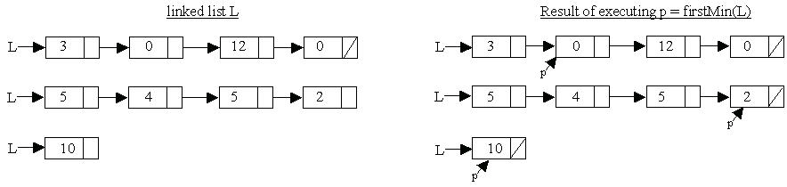

public ListNode firstMin(ListNode list) {

Part B

Write the method removeNext, whose header is given below. removeNext has one parameter p, a non-null pointer to a node of a linked list. removeNext removes the node after the one pointed to by p from the list. (If the node pointed to by p is the last node on the list, removeNext does nothing.)
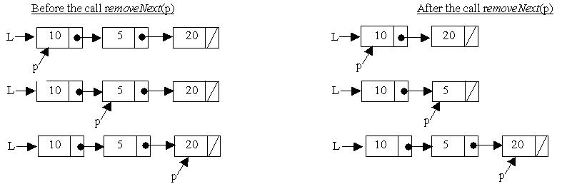
Complete function removeNext below. Assume that removeNext is called only with values that
satisfy its precondition.

public void removeNext(ListNode ptr)
// precondition: ptr != null
{

Part C

Write the method removeDupMins, whose header is given below. removeDupMins
determines the value of the smallest integer in its list parameter and removes from the list all
nodes containing that value EXCEPT the first such node. (If the list is empty, removeDupMins
does nothing.)

For example:
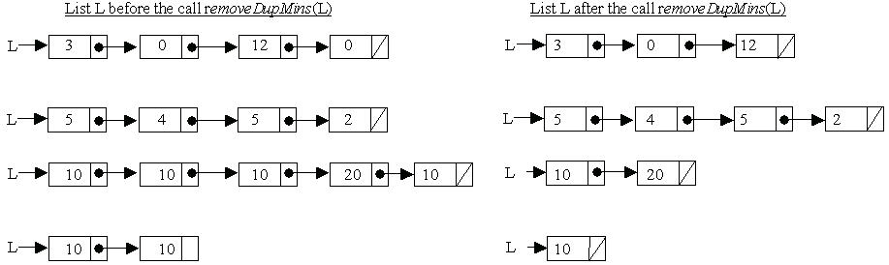

Assume that firstMin and removeNext of parts (a) and (b) work as specified, regardless of what you wrote in those parts. Solutions that reimplement functionality provided by these methods, rather than invoking them, will not receive full credit.

Complete removeDupMins below.

public void removeDupMins(ListNode list)
{

